**Внутреннее соединение таблиц**

1. Определить суммарную зарплату работников из Великобритании (страна с названием "United Kingdom").

**Ответ:** select sum(e.salary) summ from employees e

inner join departments d using (department_id)

inner join locations l using(location_id)

inner join countries c using(country_id)

where c.country_name = 'United Kingdom'

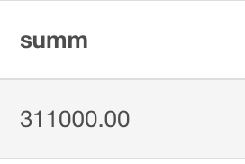

<https://www.db-fiddle.com/f/9JdN9c9fBJ8xD8SFVk6q4W/12>

1. Для каждого сотрудника из Канады найти данные о менеджере.   
   **Ответ**: select e.last_name, e.first_name, e.salary, e.manager_id, m.last_name, m.first_name, m.salary from employees e inner join departments d using(department_id) inner join locations l using(location_id) inner join countries c using(country_id) inner join employees m on e.manager_id = m.employee_id where c.country_name = 'Canada' order by e.last_name, e.first_name;

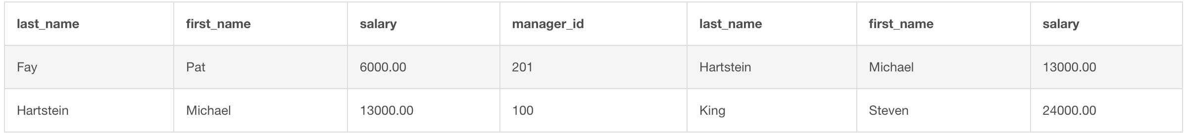

https://www.db-fiddle.com/f/9JdN9c9fBJ8xD8SFVk6q4W/13

1. Для стран, в которой трудоустроен хотя бы один сотрудник, подсчитать суммарную зарплату работников, трудоустроенных в подразделениях, расположенных в этой стране.   
   **Ответ:**

select c.country_name, sum(e.salary) summ from employees e inner join departments d using(department_id) inner join locations l using(location_id) inner join countries c using(country_id) group by c.country_id having count(e.employee_id) > 0 order by summ DESC, c.country_id

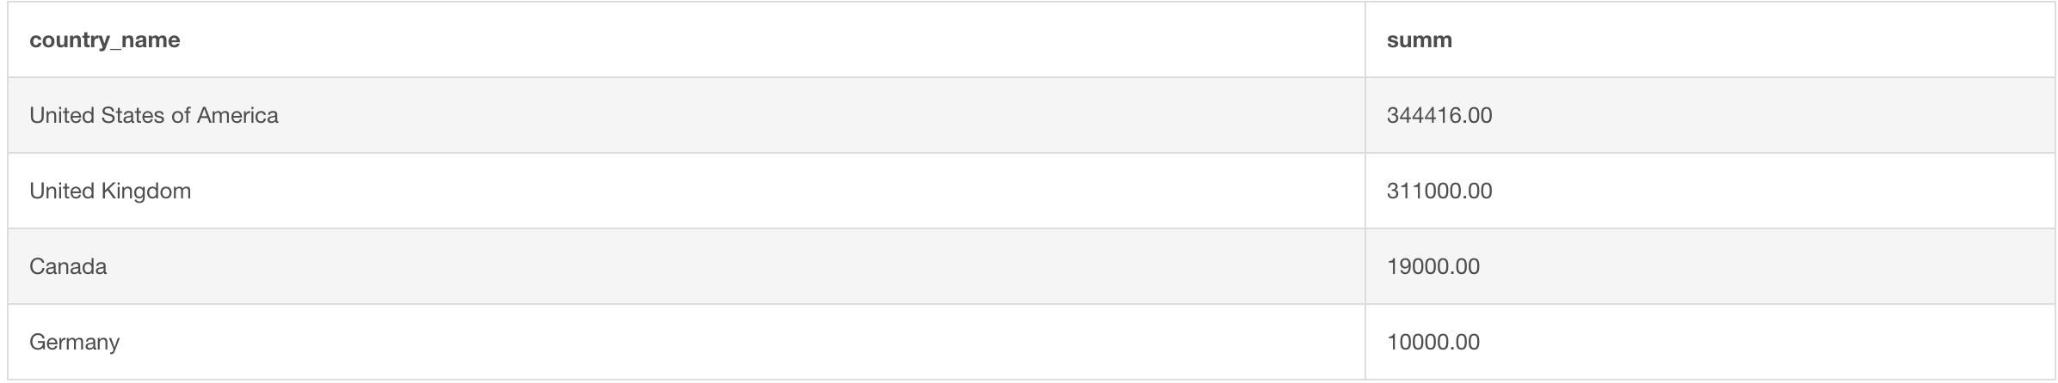

https://www.db-fiddle.com/f/9JdN9c9fBJ8xD8SFVk6q4W/13

1. Определить количество работников из Европы (регион с именем "Europe").   
   **Ответ:**

select count(*) from employees e inner join departments d using(department_id) inner join locations l using(location_id) inner join countries c using(country_id) inner join regions r using(region_id) where r.region_name = 'Europe';

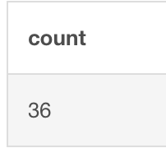

https://www.db-fiddle.com/f/9JdN9c9fBJ8xD8SFVk6q4W/15

1. Определить среднюю зарплату работников из Европы (регион с именем "Europe").  
   **Ответ:**

select avg(e.salary) from employees e inner join departments d using(department_id) inner join locations l using(location_id) inner join countries c using(country_id) inner join regions r using(region_id) where r.region_name = 'Europe';

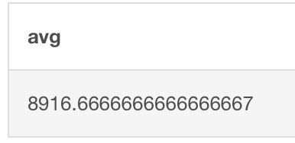

https://www.db-fiddle.com/f/9JdN9c9fBJ8xD8SFVk6q4W/16

1. Определите все должности встречающиеся в странах Европы   
   **Ответ:**

select distinct j.job_title, c.country_name from employees e inner join jobs j using(job_id) inner join departments d using(department_id) inner join locations l using(location_id) inner join countries c using(country_id) inner join regions r using(region_id) where r.region_name = 'Europe' order by c.country_name, j.job_title;

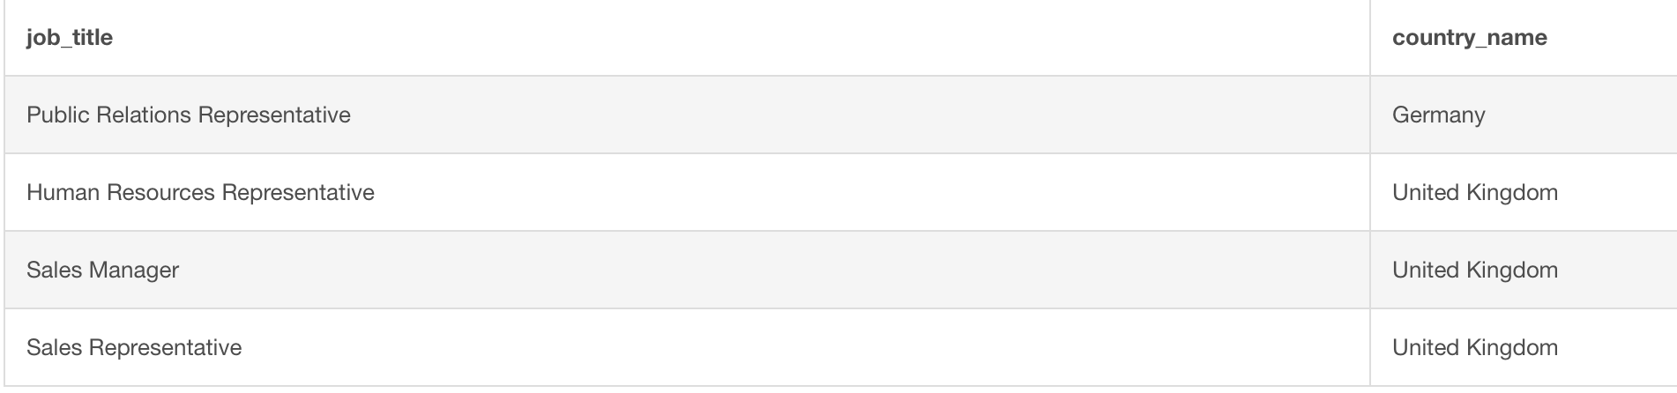

https://www.db-fiddle.com/f/9JdN9c9fBJ8xD8SFVk6q4W/18

1. Определить год, в котором было трудоустроено больше всего человек.    
   **Ответ:**

select extract(year from hire_date) as yearr from employees group by extract(year from hire_date) order by count(*) DESC limit 1;

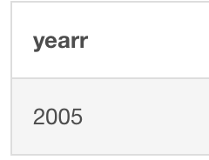

https://www.db-fiddle.com/f/9JdN9c9fBJ8xD8SFVk6q4W/19

1. Определить работника (работников), который эффективнее всех продвинулся по карьерной лестнице. Под эффективностью будем понимать разницу максимальной зарплаты на новой должности и минимальной на старой должности.    
   **Ответ:**

with career_growth as (

select jh.employee_id, max(j_new.max_salary) - min(j_old.min_salary) as growth

from job_history jh

inner join jobs j_old on jh.job_id = j_old.job_id

inner join employees e on jh.employee_id = e.employee_id

inner join jobs j_new on e.job_id = j_new.job_id

group by jh.employee_id)

select e.employee_id as id_employee, e.first_name as fiirst_name, e.last_name as laast_name, d.department_name as department

from employees e

inner join career_growth cg on e.employee_id = cg.employee_id

inner join departments d on e.department_id = d.department_id

where cg.growth = (select max(growth) from career_growth)

order by e.employee_id;



https://www.db-fiddle.com/f/9JdN9c9fBJ8xD8SFVk6q4W/21

1. Найти всех таких сотрудников, менеджер которых трудоустроен в другом отделе.   
   **Ответ:**

select e.employee_id, ed.department_name as employee_department, ec.country_name as employee_country, e.manager_id, md.department_name as manager_department, mc.country_name as manager_country

from employees e

inner join departments ed using(department_id)

inner join locations el using(location_id)

inner join countries ec using(country_id)

inner join employees m on e.manager_id = m.employee_id

inner join departments md on m.department_id = md.department_id

inner join locations ml on md.location_id = ml.location_id

inner join countries mc on ml.country_id = mc.country_id

where e.department_id != m.department_id

order by e.employee_id;

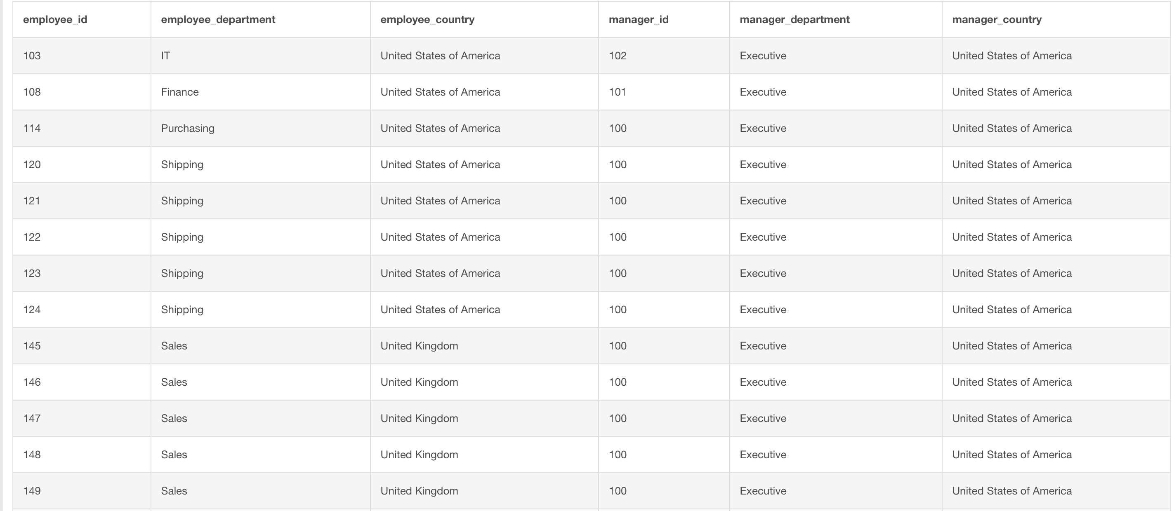

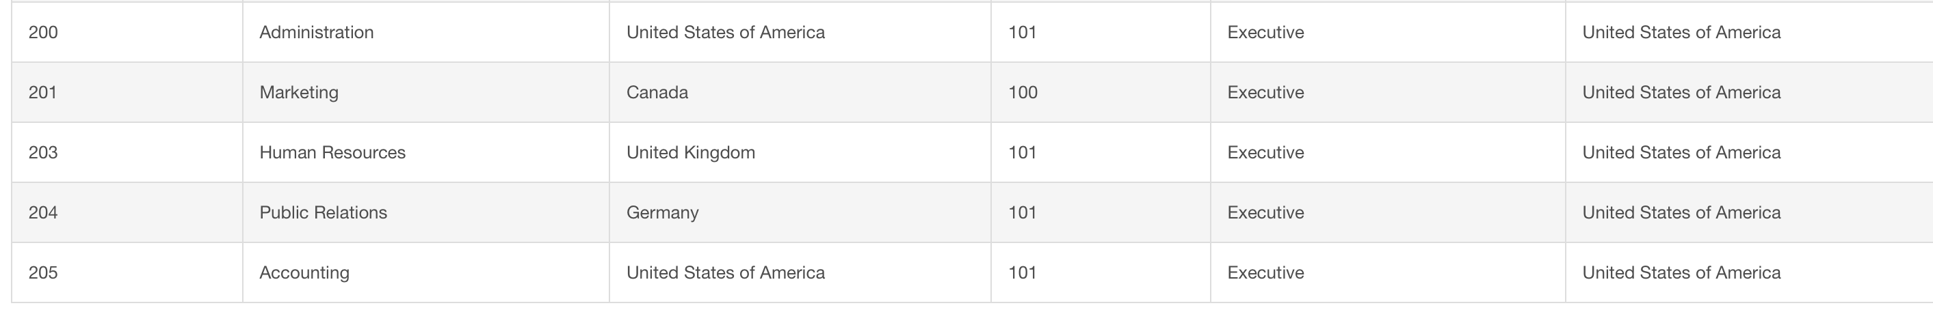

https://www.db-fiddle.com/f/9JdN9c9fBJ8xD8SFVk6q4W/20